Software Design Method

Final Group Project

HealthCare Information System

Rui Zhu

Lingjing Huang

Entisar Seedi M Alshammry

1. Motivation (Describe the reason you picked the topic)

Health Care Information Systems is designed for improving hospital's cost control, increase the timeliness and accuracy of patient care and administration information, increase service capacity, reduce personnel costs and improve the quality of patient care. However, experience shows that most of these benefits will not occur automatically following system implementation. Operational problems may exist that diminish information timeliness, accessibility, and accuracy; policies and procedures may not have been sufficiently tailored to reflect the realities and intents of the systems, and personnel tasks may not have been adequately restructured. In order to realize the full potential of information systems, health care organizations must plan for and implement strategies that are designed to maximize such benefits. So we use what we learn in the Software Design Method class to build a more user-friendly and more efficient Health Care Information System.

1. Discuss related work (literature survey)

After reading the paper <Best Practices in the Design and Development of Health Care Information System>, we acquired two important points for the system:

One of the most important constraints of the medical data is the need to permanently adjust the items of data to be stored in the database. Some data architecture patterns are presented, which enable the information systems to support those adjustments without any change of the data model or software application, providing scalability in design to the systems. Another issue related to medical data is the possible existence of different terms for the same concept. This is usually the case when legacy data are imported, or when medical teams from different specializations are using the same system.

There is a useful website: “http://www.open-emr.org”, which is a fully build Health System. OpenEMR is an open source electronic health records and medical practice management software can be downloaded on the Internet for free, contains such as Scheduling, Medical Billing, Clinical Decision Rules functions and so on. This website gives us a more straightforward acknowledge of the Health Care System and inspire us the following steps from use cases through coding.

At last, the textbook (Applying UML and Patterns: An Introduction to Object-Oriented Analysis and Design and Iterative Development) is the most important resource for the final project, by which guiding us the correct format and contents of the Use Case, Domain Model, SSD, DCD.

1. Use Cases Context
2. Patient admission registration / create patient
3. Medical records - Review / add patient medical records
4. Treatments - Schedule /view / update /cancel treatment / lab
5. Prescribe medication
6. Reorder medication (patient refills / reorders medication)
7. Process medical payment
8. Details of Each Use Cases
   1. Patient admission registration
      * 1. Fully Dressed Template

|  |  |
| --- | --- |
| Primary Actor | Front desk |
| Stakeholders and Interests: | * Doctor: wants patients registered as required; * Patient: wants to register to admit the hospital; * Front desk: wants to add the patient and his/her treatment to the system without errors; * Hospital: wants to accurately record the patient’s and the treatment’s information. Wants to ensure the payment. |
| Success Guarantee | The front desk receives the confirmation message |
| Main Success Scenario | 1. System asks user to select the identity type 2. User selects “patient”. 3. System asks for patient’s name and date of birth. 4. The user enters name and date of birth. 5. System searches this information in the patients’ information database. 6. System returns the result and asks user to select the action to take. 7. User selects “register for admission”. 8. System displays the admission registration form. 9. User enters patient ID, department, admission time, room number, bed number, ward number to the system. 10. System searches this information in treatment database and returns the result 11. System adds the new treatment to the treatment database. 12. System display the confirmation message. |
| Extensions | 6a. In step 6 of the main scenario, system find the patient information does not exist in the database   1. System returns the message that cannot find the patient information in database, and displays the form of patient information 2. User enters the patient’s name, gender, date of birth, address, contact number and insurance information to the system. 3. System creates a new patient information and saves in the database.   11a. In step 11, if the result shows that this treatment already exists in the database,   1. System returns the message that the treatment exists. |
| Special Requirements |  |

* + - 1. Domain Model

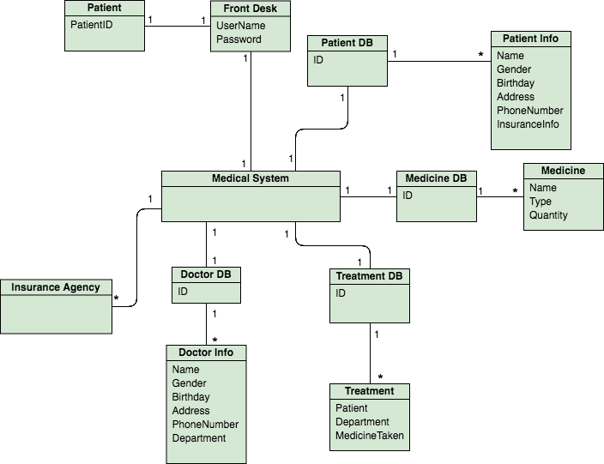

* + - 1. Sequence Diagram

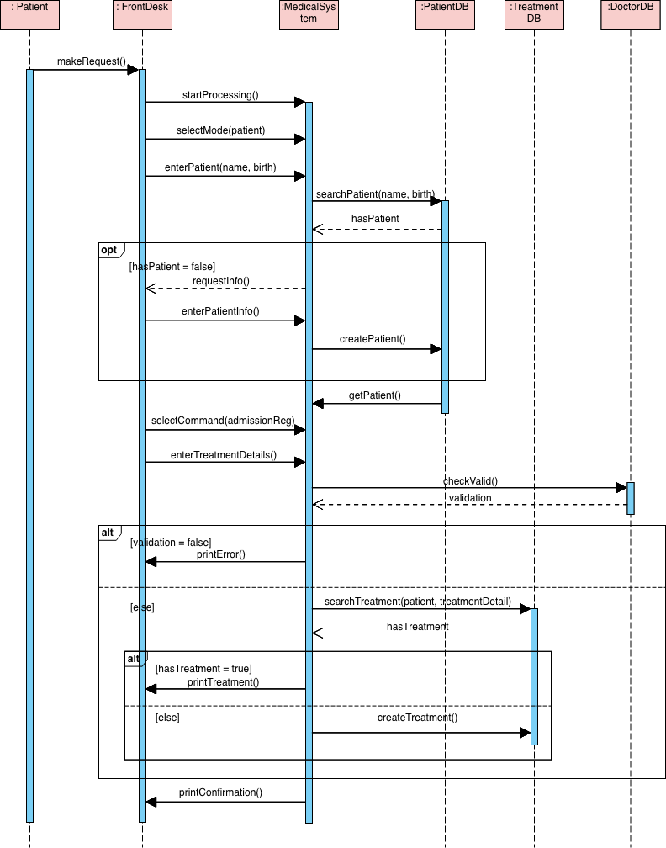

* + - 1. GRASP Principle

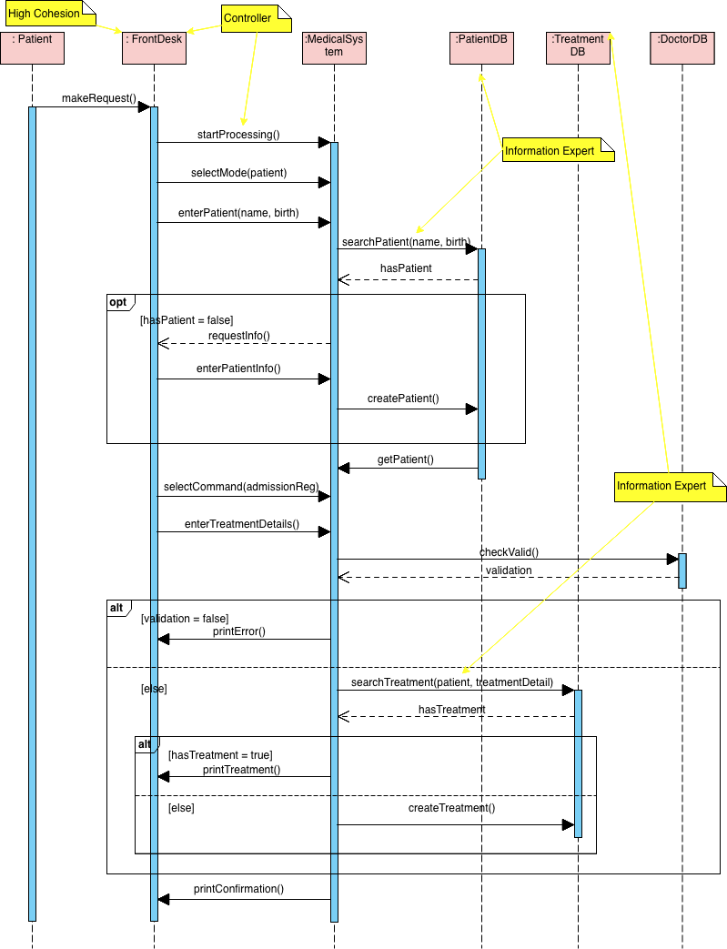

* + - 1. Design Class Diagram

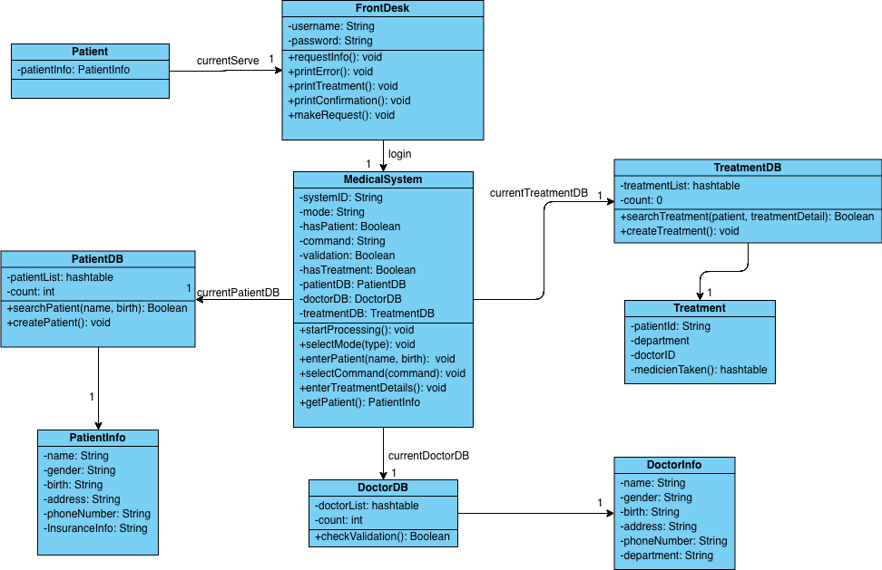

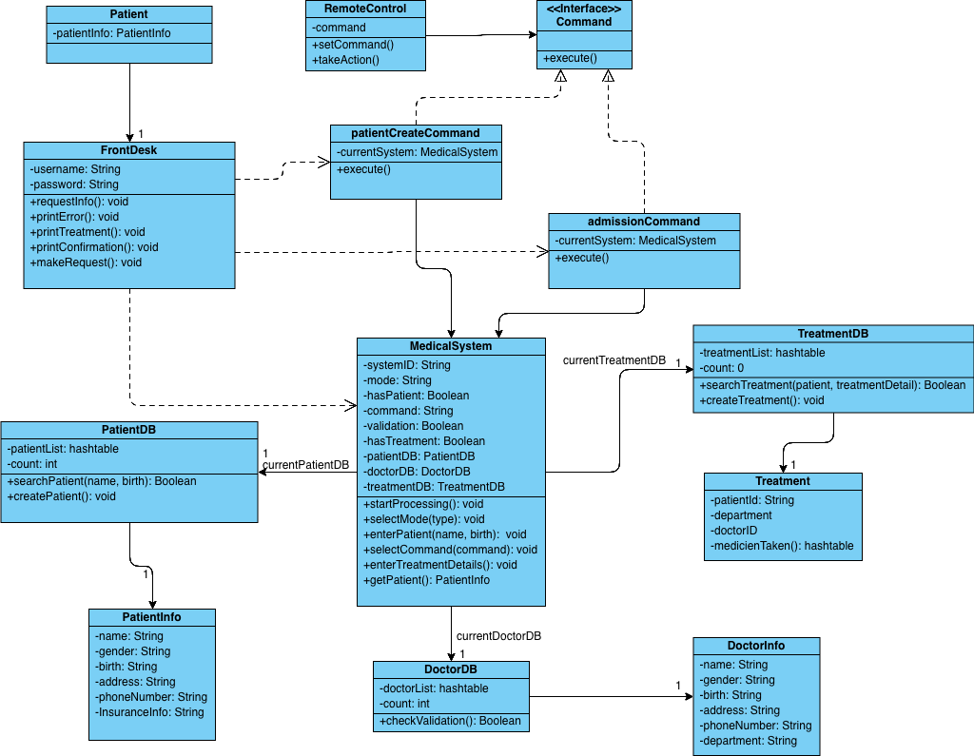

* 1. Medical records - Review / add patient medical records
     + 1. Fully Dressed Template

|  |  |
| --- | --- |
| Primary Actor | Doctor |
| Stakeholders and Interests: | * Doctor: wants patients medical record display correctly; * Patient: wants to see the medical record clearly; * Hospital: wants to accurately record the patient’s and the medical information. |
| Success Guarantee | Doctors or patients can inquiries medical records on the system. |
| Main Success Scenario | 1. Doctor uses system to inquiries the patient’s medical records by using patient’s name and ID. 2. The medical system returns the medical records to the doctor, if the patient has the medical on the system. 3. Doctor select “Add” function to add a new medical record. 4. Doctor finish all describe of the treatment details, and save to the system. 5. Once the record saved the system returns the information “New medical record added successfully!” |
| Extensions | 2a. The patient is a new patient to the hospital and doesn’t have the medical record on the system.  1. The system shows there is 0 record on the system.  2. And ask to start the first medical record.  5a. The record doesn’t save successfully, the system returns the information “Please try again.” |
| Special Requirements |  |

* + - 1. Domain Model

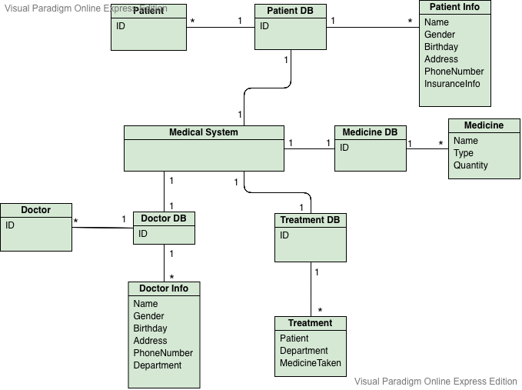

* + - 1. Sequence Diagram

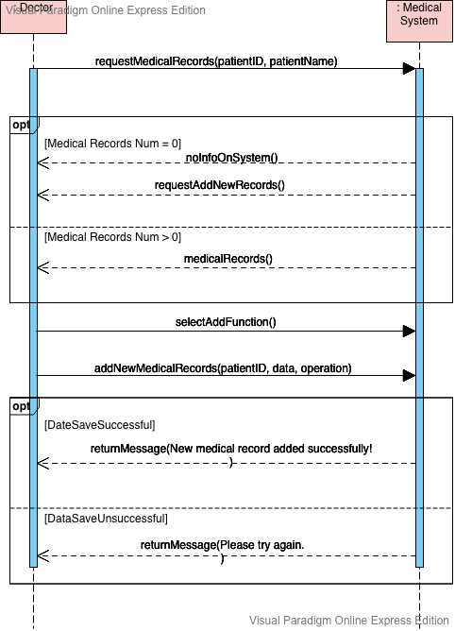

* + - 1. GRASP Principle

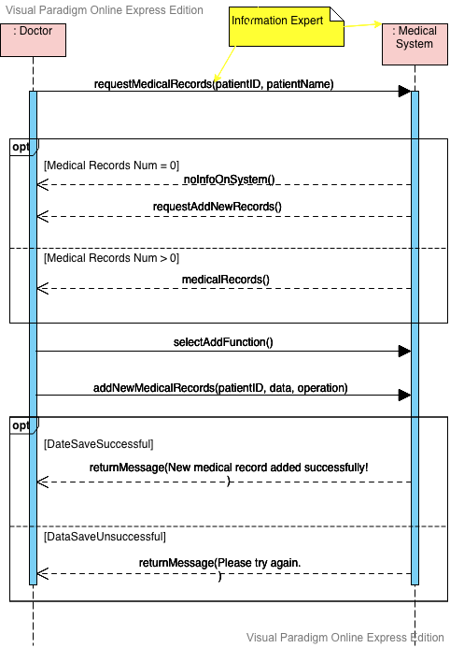

* + - 1. Design Class Diagram

//////TODO

* 1. Treatments - Schedule /view / update /cancel treatment / lab
     + 1. Fully Dressed Template

|  |  |
| --- | --- |
| Primary Actor | Doctor |
| Stakeholders and Interests: | * Doctor: wants patients’ Treatment display correctly; * Patient: wants to see the treatment details clearly; * Hospital: wants to accurately record the patient’s and the treatment information. |
| Success Guarantee | Doctors or patients can inquiries treatment details on the system. |
| Main Success Scenario | 1. Doctor uses system to inquires the treatment details by entering patients name and treatment date, and the treatment details exist. 2. Doctor modify the treatment information, and save to the system. 3. After save the treatment details successfully, the system shows the successful sentences. |
| Extensions | 1a. If the treatment doesn’t exist, the system hint that the treatment doesn’t exist on the system, and ask to add a new treatment.  3a. If the treatment details don’t save successfully, the system shows unsuccessful sentences. |
| Special Requirements |  |

* + - 1. Domain Model



* + - 1. Sequence Diagram

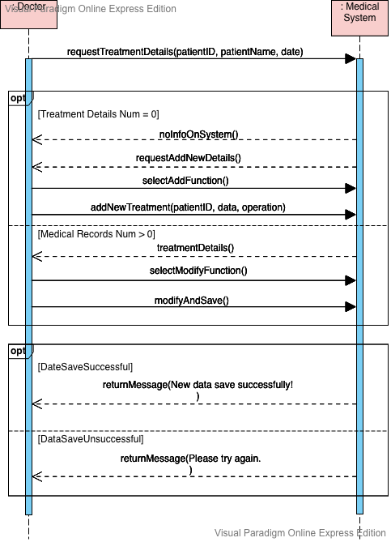

* + - 1. GRASP Principle

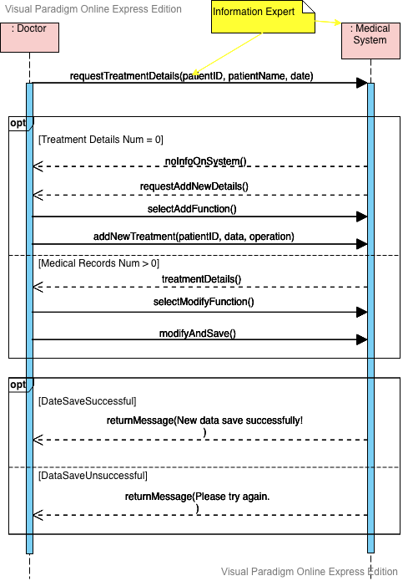

* + - 1. Design Class Diagram

////TODO

* 1. Process medical payment
     + 1. Fully Dressed Template

|  |  |
| --- | --- |
| Primary Actor | Hospital Cashier |
| Stakeholders and Interests | * Hospital Cashier: Wants accurate, fast entry, and no payment errors, as cash drawer shortages are deducted from his/her salary * Doctor: Wants patients get their medicine quickly, and be healthy as soon as possible * Patient: Wants purchase and fast service with minimal effort. Wants easily visible display of medicine and prices in receipt. * Hospital: Wants to accurately record transactions and satisfy patient requirements. Wants to ensure that Payment Authorization Service payment receivables are recorded. Wants some fault tolerance to allow medicine sales capture even if server components (e.g., remote credit validation) are unavailable. Wants automatic and fast update of accounting and inventory. * Payment Authorization Service: Wants to receive digital authorization requests in the correct format and protocol. Wants to accurately account for their payables to the hospital. |
| Preconditions | Hospital cashier is identified and authenticated. Doctor has already made a prescription for patient in hospital medical system. |
| Success Guarantee | Medical sale is saved. Accounting and Inventory are updated. Commissions recorded. Receipt is generated. Payment  authorization approvals are recorded. |
| Main Success Scenario | 1. Patient arrives at hospital front desk and checks out by his patient identify number to purchase.  2. Hospital cashier starts a new sale.  3. Hospital cashier enters patients ID.  4. System displays medicine name and their description, price, and running total. Price calculated from a set of price rules.  5. System presents total with calculated taxes.  5. System prints a list for medicine name and quantity to pharmacist.  6. Pharmacist picks up medicines by following the medicine list to front desk.  7. Hospital cashier scans each medicine.  8. Hospital cashier tells Patient the total, and asks for payment.  9. Patient pays and System handles payment.  10. System logs completed sale and sends sale to Inventory system (to update inventory).  11. System presents receipt.  12. Patient leaves with medicine and receipt. |
| Extensions | 3a. Invalid Patient ID(not found in the system):   1. System signals error and reject entry. 2. Hospital cashier responds to the error:   1. Hospital cashier check with the doctor.  2. Hospital cashier enters the patient ID again.  8a. Paying by cash:   1. Cashier enters the cash amount tendered. 2. System presents the balance due, and releases the cash drawer. 3. Cashier deposits cash tendered and returns balance in cash to Customer. 4. System records the cash amount.   8b. Paying by credit:   1. Patient enters their credit account information. 2. System displays their payment for verification. 3. Cashier confirms. 4. System sends payment authorization request to an external Payment Authorization Service System, and requests payment approval.   4a. System detects failure to collaborate with external system:  1. System signals error to Cashier.  2. Cashier asks Customer for alternate payment.   1. System receives payment approval, signals approval to Cashier, and releases cash drawer (to insert signed credit payment receipt).   5a. System receives payment denial:  1. System signals denial to Cashier.  2. Cashier asks Customer for alternate payment.  8c. Paying by debit…  11a. Printer out of paper   1. If System can detect the fault, will signal the problem. 2. Cashier replaces paper. 3. Cashier requests another receipt. |
| Special Requirements | * Touch screen UI on a large flat panel monitor. Text must be visible from 1 meter. * Credit authorization response within 30 seconds 90% of the time. * Somehow, we want robust recovery when access to remote services such the inventory * system is failing. * Language internationalization on the text displayed. |
| Technology and Data Variations List | 7a. Medicine scanned by bar code laser scanner (if bar code is present) or keyboard.  8a. Credit account information entered by card reader or keyboard.  8b. Credit payment signature captured on paper receipt. But within two years, we predict many customers will want digital signature capture. |
| Frequency of Occurrence | Could be nearly continuous |

* + - 1. Domain Model

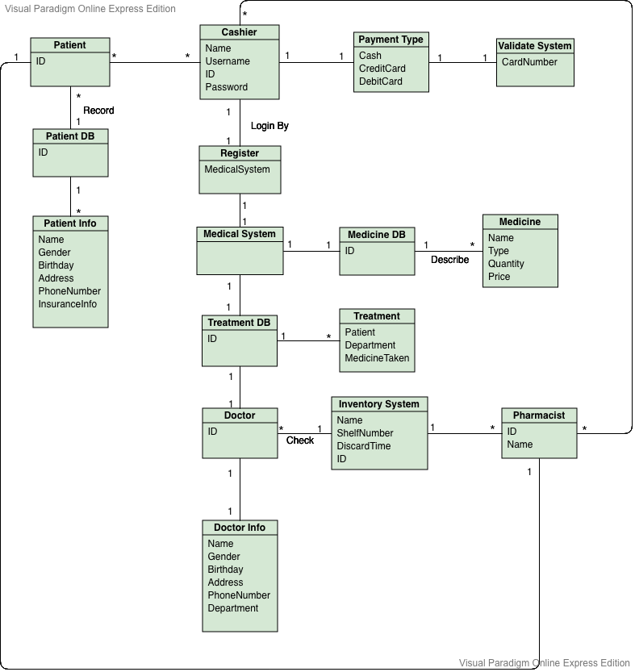

* + - 1. Sequence Diagram
      2. GRASP Principle
      3. Design Class Diagram

////TODO

5. Conclusion

////TODO